For today’s class you will be working by stations.
Station 1: (Individual) – 10 mins
- Using internet, look for the definition of what a diagram is and take notes in your notebook.
- Open chapter 3 about creating diagrams and read it. Look at the various examples of diagrams.
Station 2: (Groups of 3) – 10 mins
Here is the division of the groups.
Groups
Station 3 | Station 4
Group 1:  Name 1  Name 2  Name 3  Group 2:  Name 4  Name 5  Name 6  Group 3:  Name 7  Name 8  Name 9 | Group 1:  Name 10  Name 11  Name 12  Group 2:  Name 13  Name 14  Name 15  Group 3:  Name 16  Name 17  Name 18

Imagine you are going to make a presentation about a teaching method. Read the following description and discuss how you could show this in a diagram. Take notes of your ideas in your notebooks.
<<The classroom is organized in 6 stations. In station 1 and 2, students are placed in groups of 3 and will be working on an explanation of a topic through an online reading with laptops. They only have 10 minutes. There are nine students in each of the stations. Then, students are asked to go to stations 3 and 4 in the same groups. They are given an activity they must discuss as a group. Students take notes in their notebooks. They have 10 minutes. Finally, students pass to stations 5 and 6 in the same groups that had worked on the previous ones. Each group must work with one laptop and complete an activity assigned by the teacher. For this activity, they have 30 minutes.>>

Station 3: (Groups of 3 – same groups) – 30 mins
Follow these steps:
1) Go to https://www.draw.io/
2) Click on Google drive
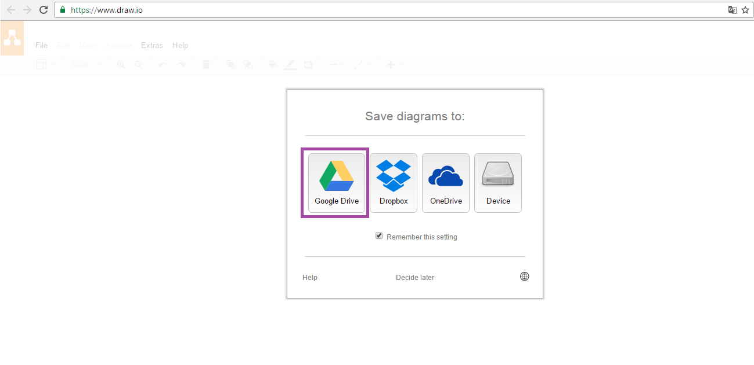
3) Click authorize.
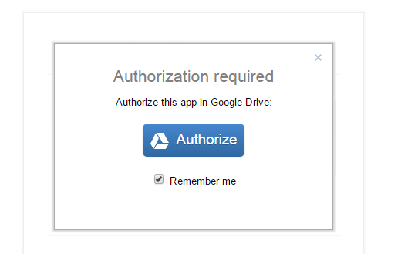
4) Click añadir cuenta.
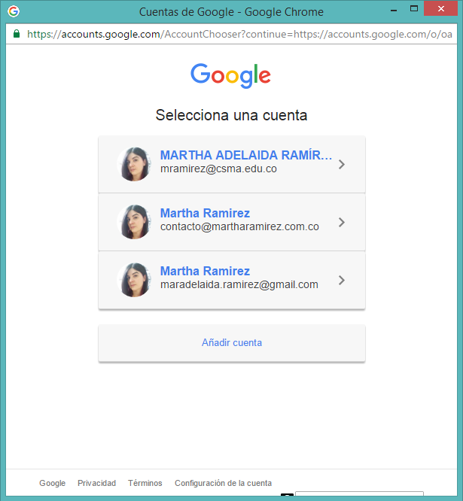
5) Choose one person responsible in the group to save the diagram. That person must write log in with their school email (username and password).
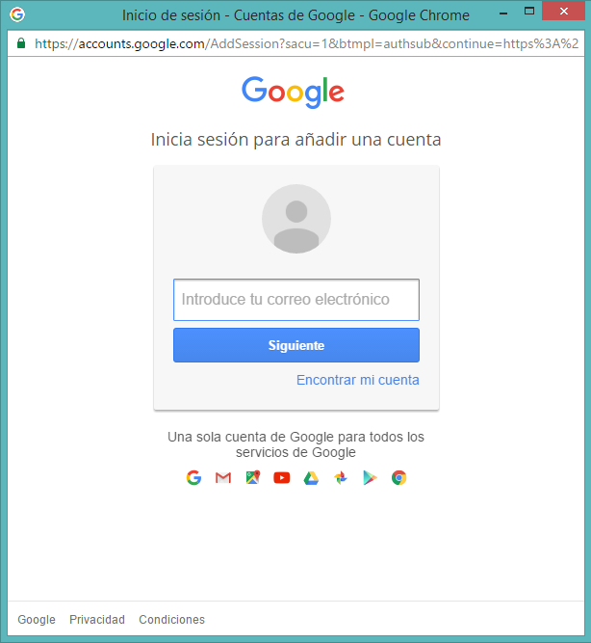
6) Click permitir.
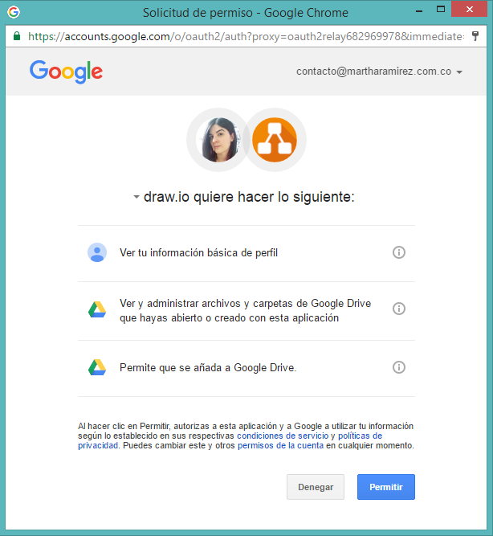
7) Click create new diagram.
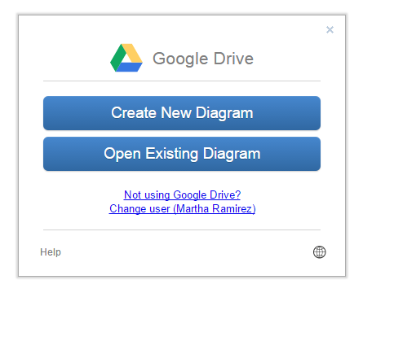
8) Give the diagram a name and then click on create.
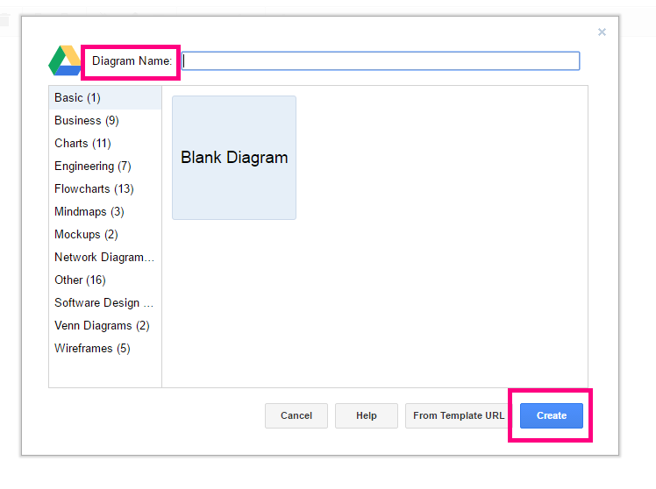

9) Click SHARE and then write my email: mramirez@csma.com.co. Finally, click on LISTO.
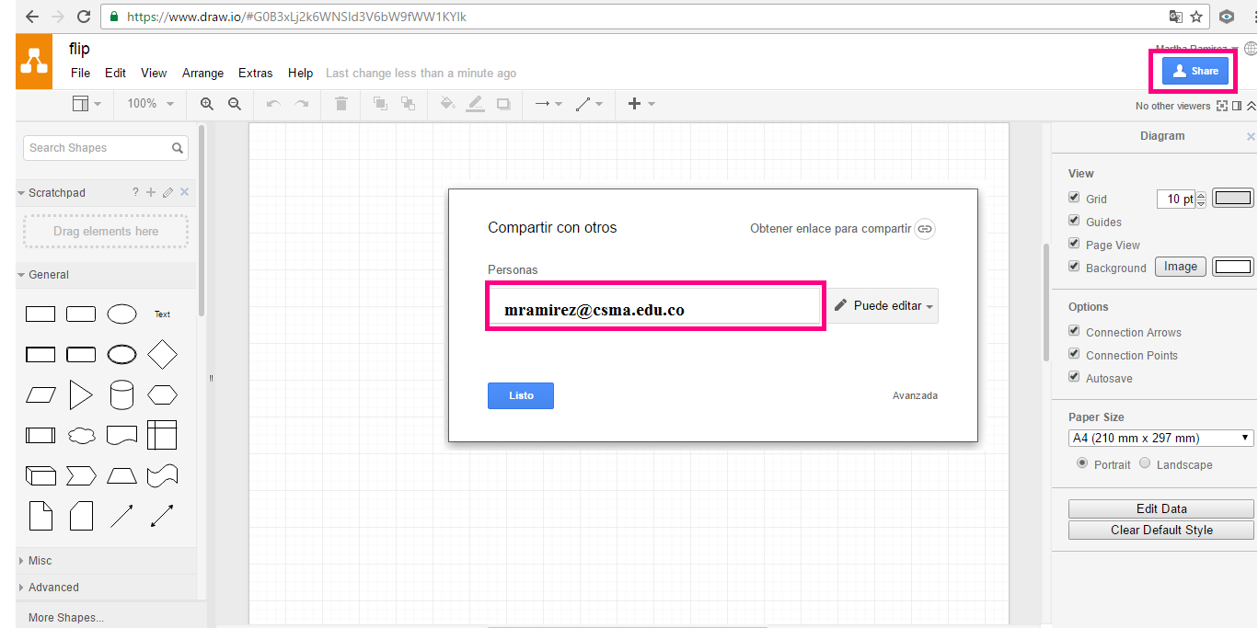

10) Explore the tool and start working! You must create the diagram for the description on exercise 2.
11) Upload you diagram to Edmodo.

